Data Mart Analysis

Step by Step Screen shots

Step 1:

Set the environmental variables as below

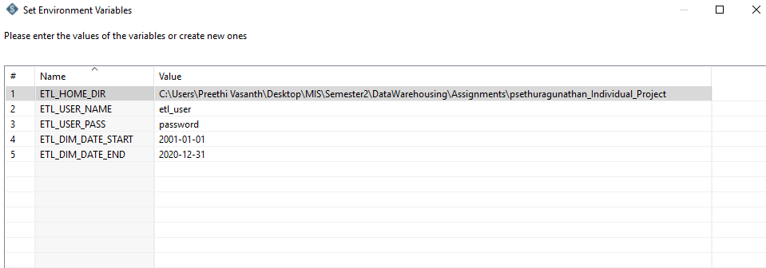

Step 2:

Created the databases in MySQL server using the given DDL scripts

Source_db: datamart_db:

Product_raw dim_product

Customer_raw dim_customer

Sales_raw dim_date

dim_fact_sales

Screenshot

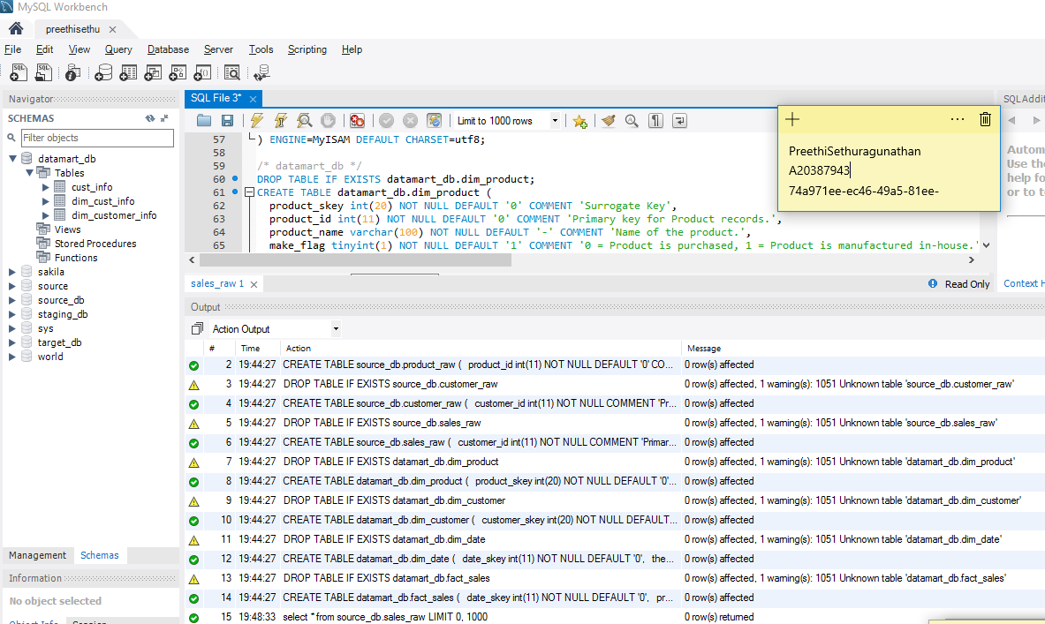

Extract-customer transformation to read the source file into the table in the source_db

Screenshot

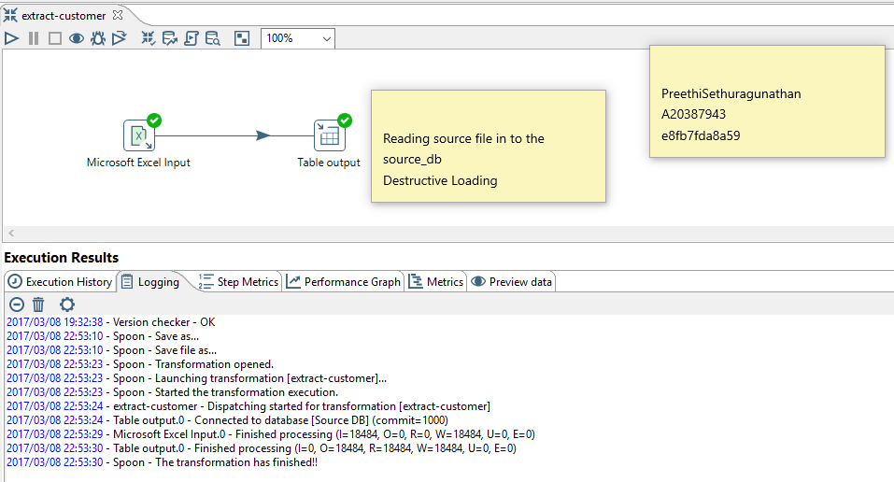

Source file successfully read into source_db.customer_raw;

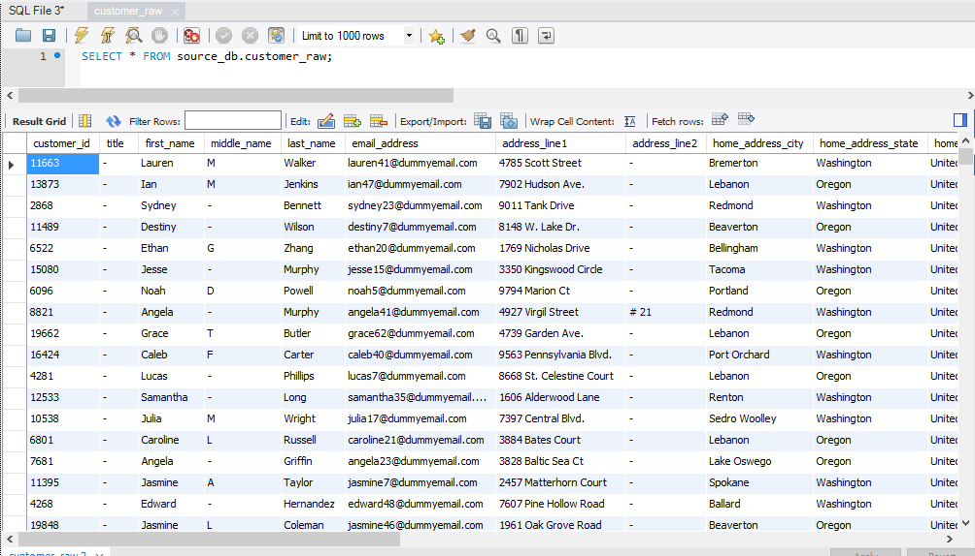

Extracting product source file into source_db.product_raw

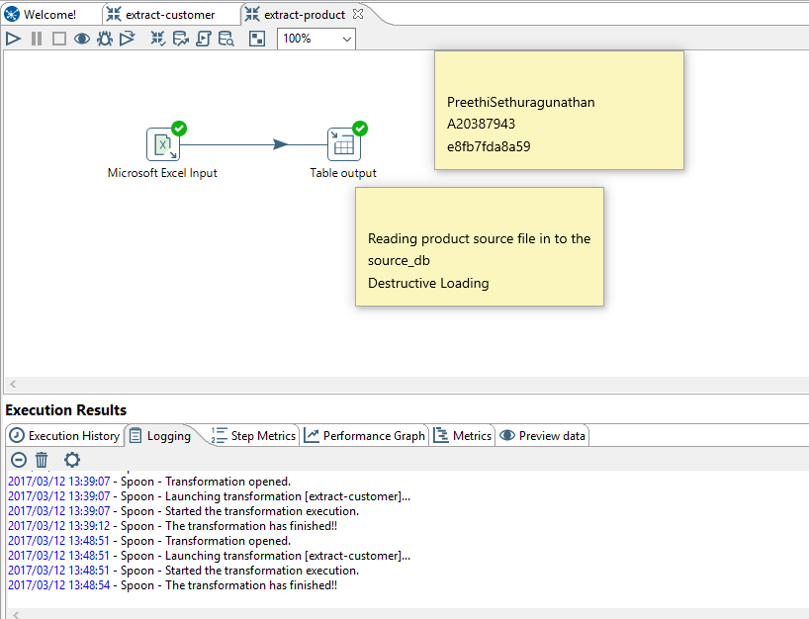

Product.xls successfully read into source_db.produce_raw

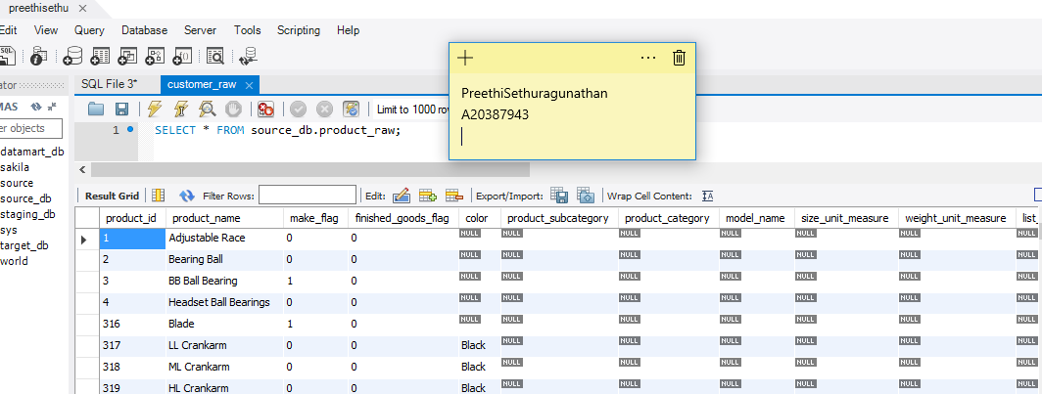

Extracting sales.csv to the source database in the sales_raw table

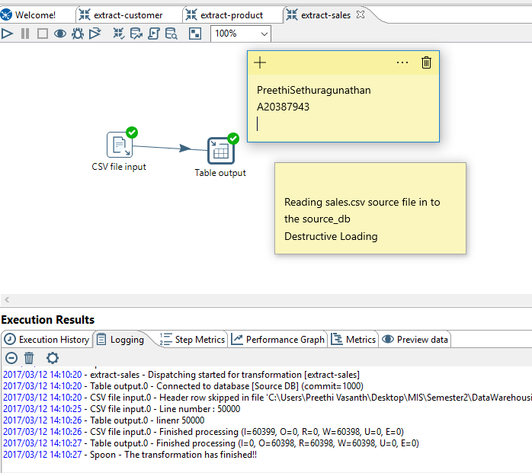

Sales.csv successfully into read into source_db.sales_raw

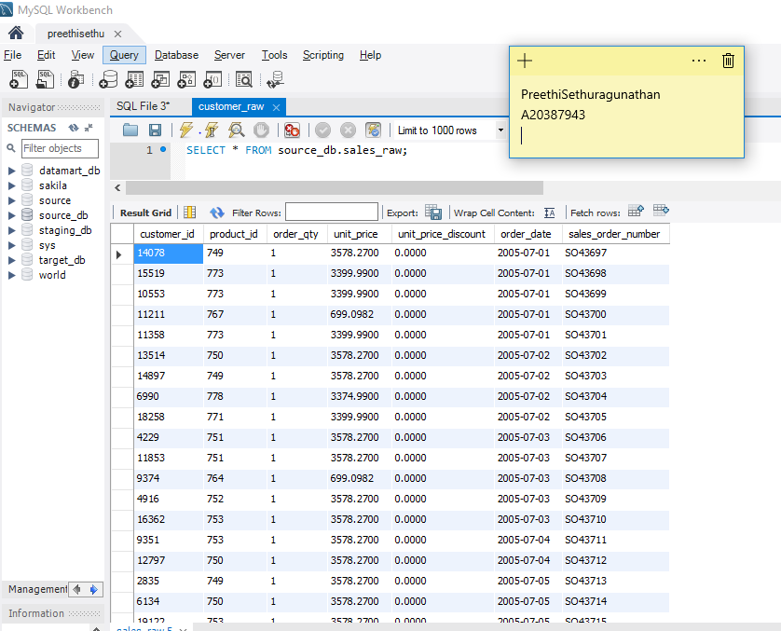

Extracting all the transformations into extract-all.kjb job

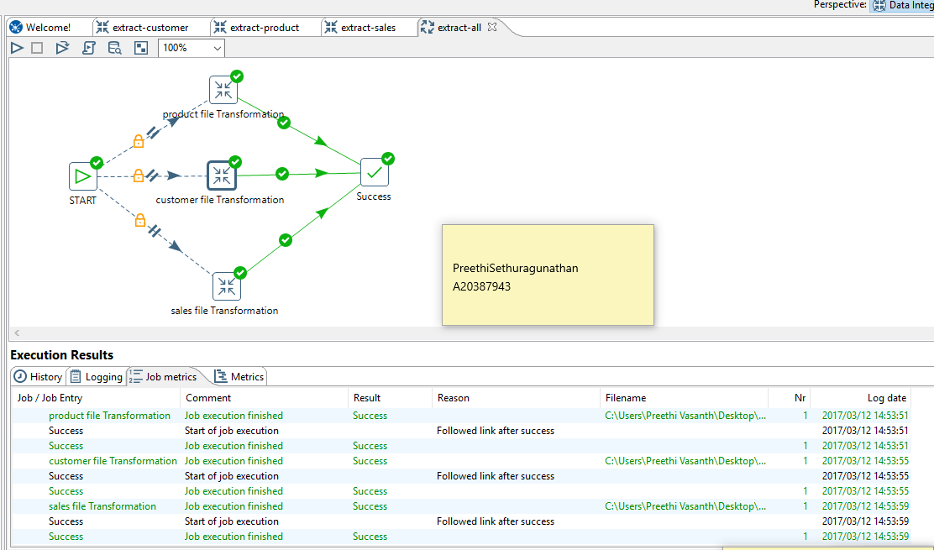

Loading dimension

load-dim-customer.ktr

loading the customer_raw table from the source_db into the dim_customer table in the datamart_db

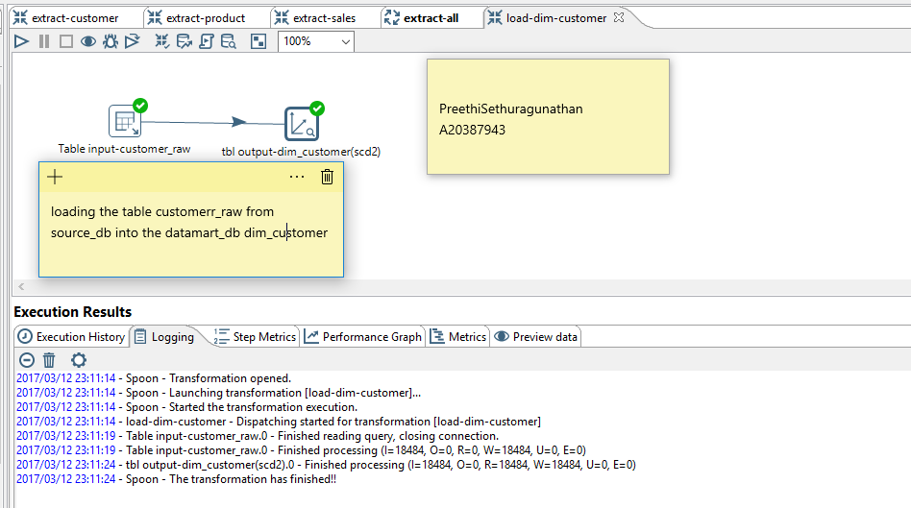

Data read from the source_db into datamart_db

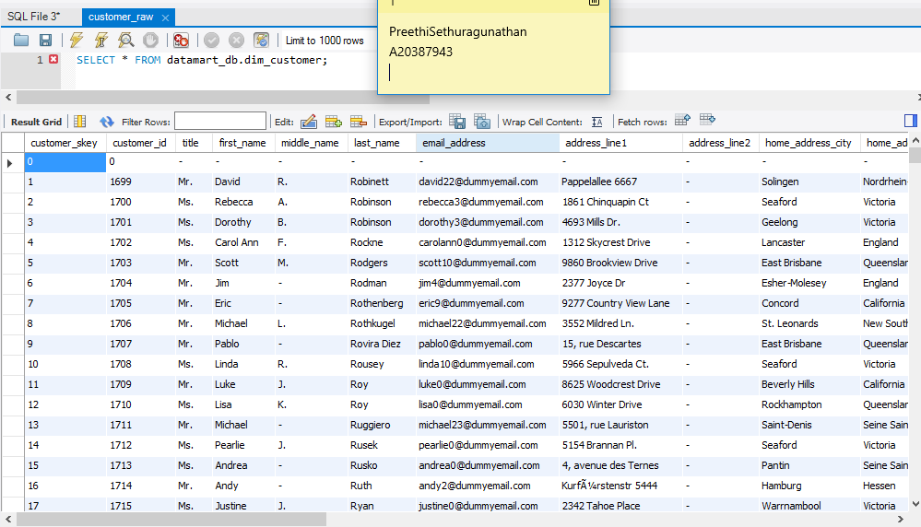

Load-dim-product

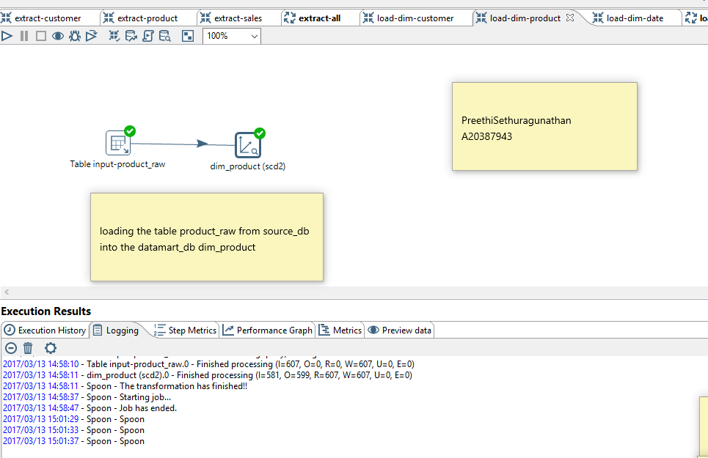

Data read into datamart_db

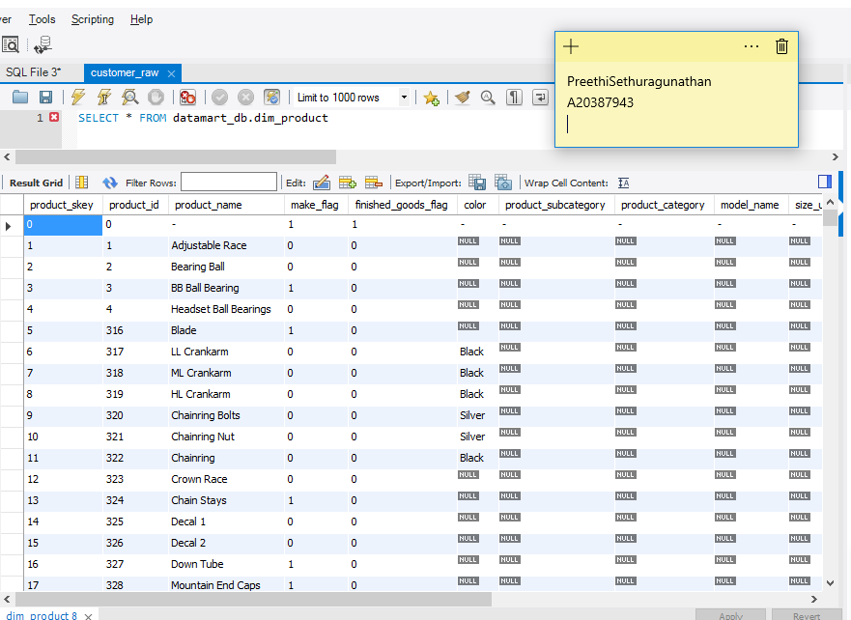

Load dim_date executed as given

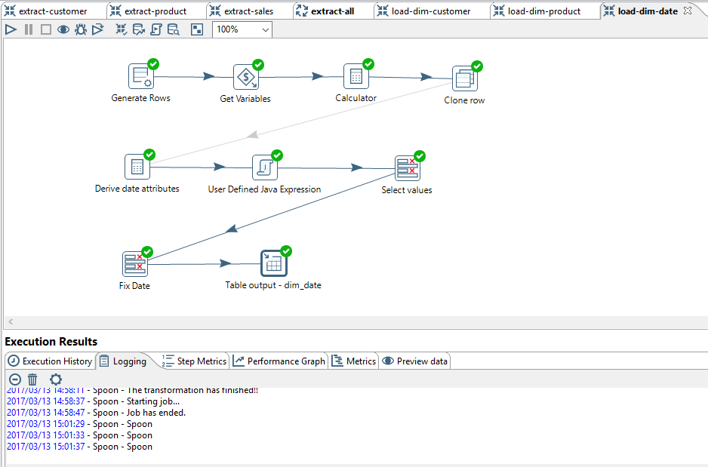

Load dim all transformation

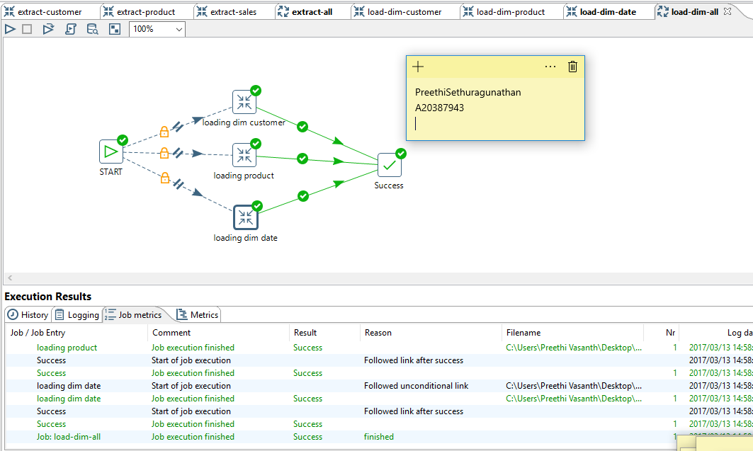

Loading fact_sales

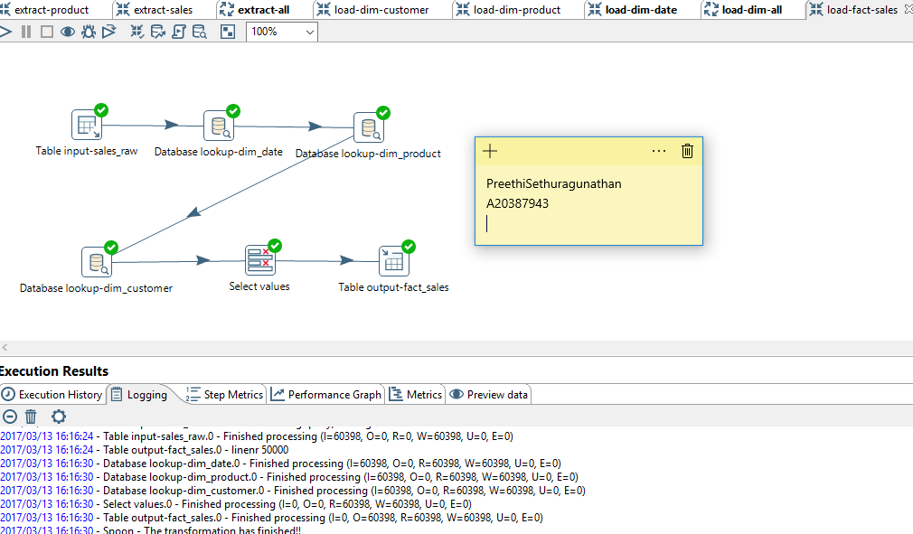

Final job-datamart-sales

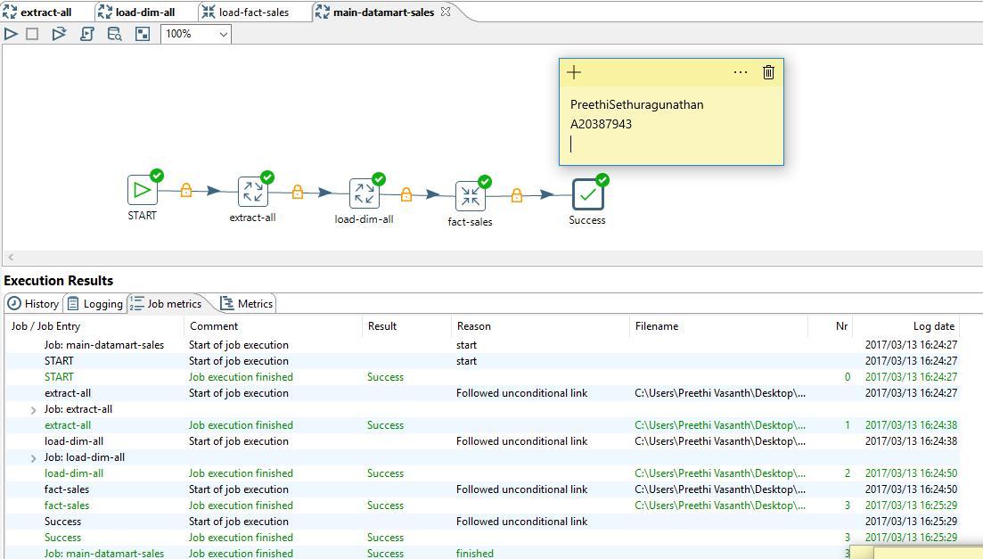

Continuation screenshots of Assignment3 modified individual project)

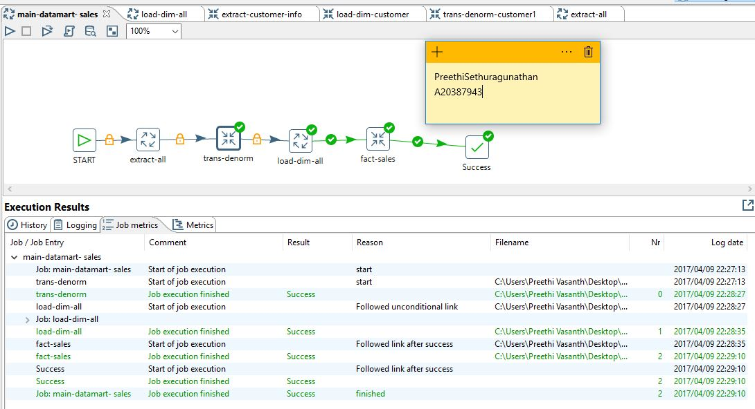

Extract-customer-info.ktr

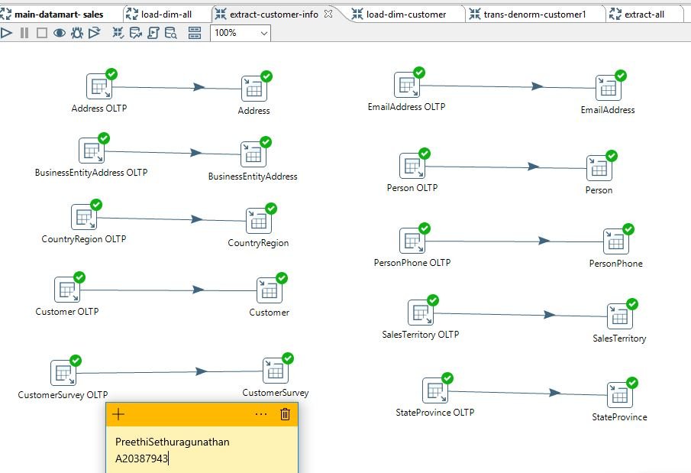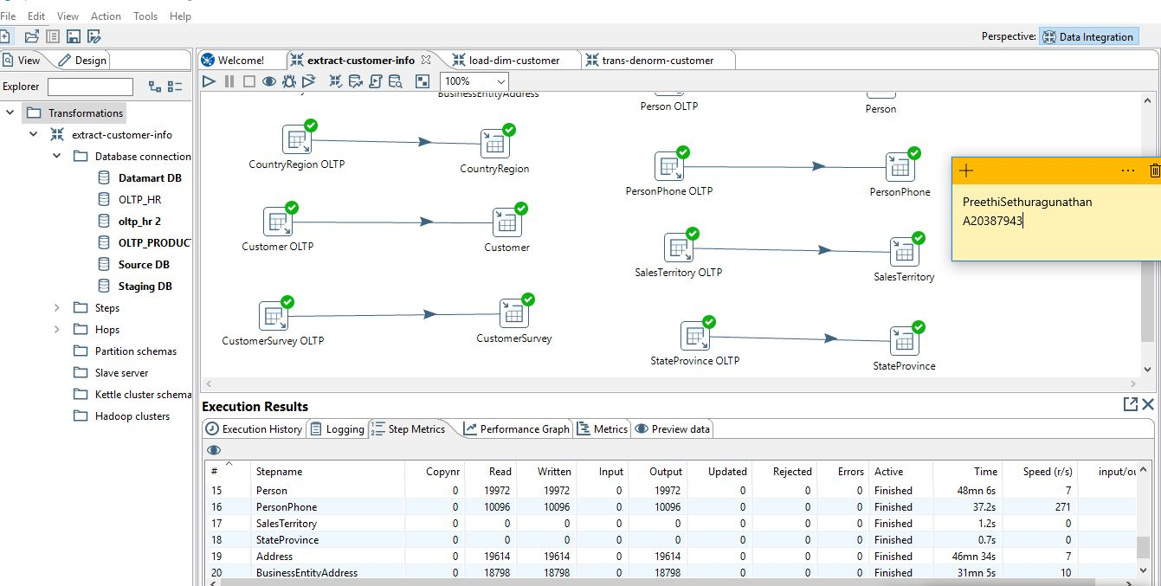

Trans-denorm-customer1

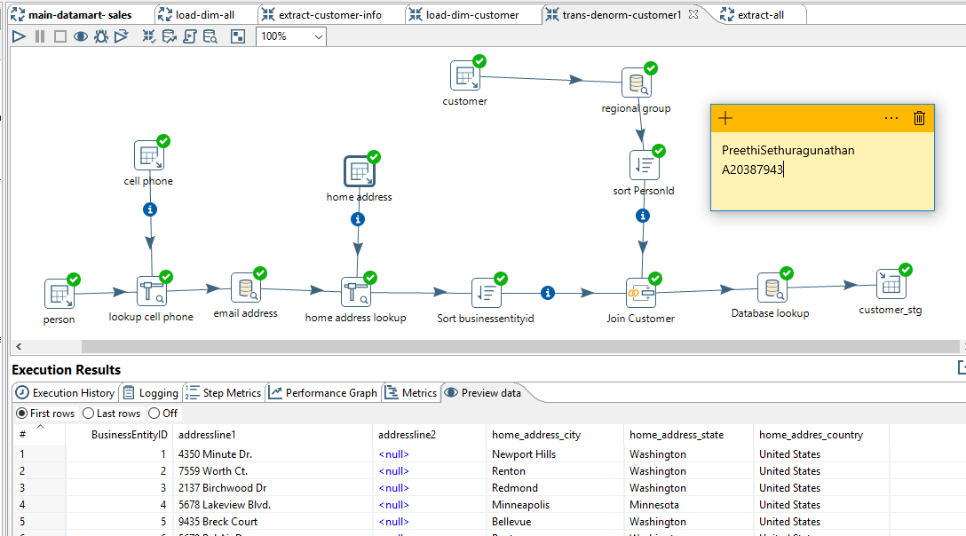

Load-dim-customer

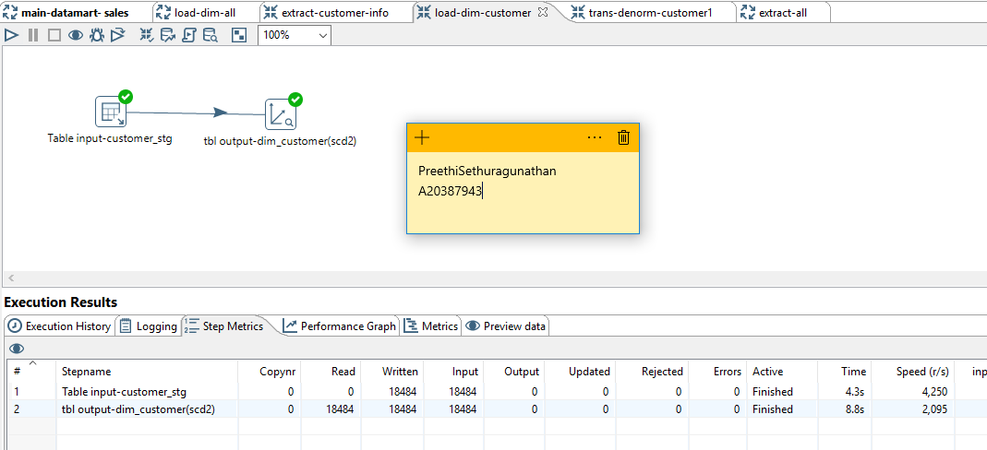

Datamart_db.dim_customer

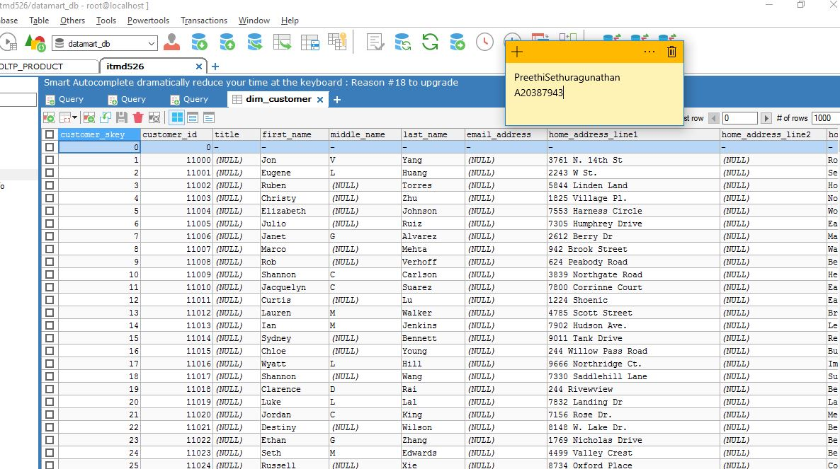

Datamart_db.fact_sales

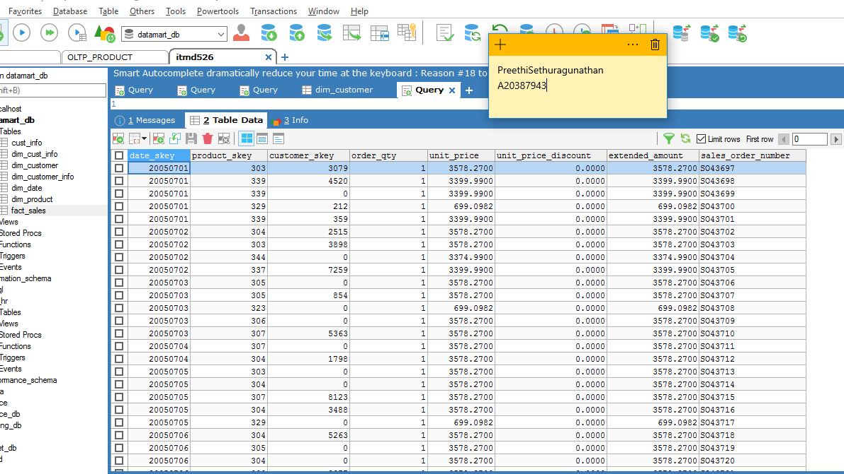

Staging_db.customer_stg

